# REAL-TIME RIVER QUALITY MONITORING AND CONTROL SYSTEM

**TEAM ID:** PNT2022TMID10977

**TEAM MEMBERS**

DEEPIKA S

JOVITA AROKIARANI A A

JAYASHREE R

JAYASRI R S

**INDEX**

1. **INTRODUCTION**
   1. **Project Overview**
   2. **Purpose 2.LITERATURE SURVEY**
   3. **Existing problem**
   4. **References**
   5. **Problem Statement Definition**
2. **IDEATION & PROPOSED SOLUTION**
   1. **Empathy Map Canvas**
   2. **Ideation & Brainstorming**
   3. **Proposed solution**
   4. **Problem Solution fit 4.REQUIREMENT ANALYSIS**
   5. **Functional requirement**
   6. **Non-Functional requirements**
3. **PROJECT DESIGN**
   1. **Data Flow Diagrams**
   2. **Solution & Technical Architecture**
   3. **Customer Journey Map**
4. **PROJECT PLANNING & SCHEDULING**
   1. **Sprint Planning & Estimation**
   2. **Sprint Delivery Schedule**
5. **CODING & SOLUTIONING**
   1. **Feature 1**
   2. **Feature 2 8.TESTING**
   3. **Test Cases 9.RESULTS**
   4. **Performance Metrics**
6. **ADVANTAGES & DISADVANTAGES**
7. **CONCLUSION**
8. **FUTURE SCOPE**
9. **APPENDIX**
   1. **Source Code**
   2. **GitHub Link**

# INTRODUCTION

* 1. **Project Overview**:

**River Water quality monitoring System** Water is one of the major compounds that profoundly influence ecosystem. But, nowadays it is been exploited heavily due to rapid industrialization, human waste and random use of pesticides and chemical fertilizers in agriculture, which leads to water contamination. Thus, a water monitoring system is necessary to observe the water quality in a large area such as lake, river, and aquaculture. As per the current world situation, Internet of Things (IoT) and remote sensing techniques are used in heterogeneous areas of research for supervising, congregate and analyzing data from the remote locations. In this paper, the suggested system is a minimal price real time water quality monitoring system in IoT environment.

This system comprise of numerous sensors for assessing the physical and chemical parameter. The factors of water that can be assessed using these sensors are pH, turbidity, conductivity, dissolved oxygen. Using this system the real time quality of water bodies can be determined and the data uploaded over the Internet are analyzed.

### Purpose:

Water quality refers to chemical, physical biological and radio logical characteristics of water. It is a measure of the condition of water relative to the necessities of one or more bio-tic species and or to any human need or purposes .Water quality monitoring is defined as a sampling and analysis of the water in lake, stream, ocean and river and conditions of the water body. Smart water quality monitoring is a process of real-time monitoring and the analysis of water to identify changes in parameters based on the physical, chemical and biological characteristics.Monitoring water quality is clearly important: in our seas, our rivers, on the surface and in our ports, for both companies and the public. It enables us to assess how they are changing, analyze trends and to inform plans and strategies that improve water quality and ensures that water meets its designated use.There are several indicators determining water quality. These include dissolved oxygen, turbidity, bio indicators, nitrates, pH scale and water temperature.Monitoring water quality helps to identify specific pollutants, a certain chemical, and the source of the pollution.There are many sources of water pollution: wastewater from sewage seeping into the water supply; agricultural practices (e.g., the use of pesticides and fertilizer); oil pollution, river and marine dumping, port, shipping and industrial activity. Monitoring water quality and a water quality assessment regularly provides a source of data identify immediate issues – and their source.

* + - Identifying trends, short and long-term, in water quality.
    - Data collected over a period of time will show trends, for example identifying increasing concentrations of nitrogen pollution in a river or an inland waterway. The total data will then help to identify key water quality parameters.
    - Environmental planning methods: water pollution prevention and management.
    - Collecting, interpreting and using data is essential for the development of a sound and effective water quality strategy. The absence of real-time data will however hamper the development of strategies and limit the impact on pollution control. Using digital systems and programs for data collection and management is a solution to this challenge.
    - Monitoring water quality is a global issue and concern: on land and at sea. Within the European Union, the European Green Deal sets out goals for restoring biological biodiversity and reducing water pollution, as well as publishing various directives to ensure standards of water quality. Individual nation states, for example France, have also clear regulatory frameworks requiring the effective monitoring of water quality. In the United States, the Environmental Protection Agency (EPA) enforces regulations to address water pollution in each state. Across the world, countries increasingly understand the importance of effective water quality monitoring parameters and methods.

1. **LITERATURE SURVEY**

### Existing Problem:

Due to population growth, urbanization ,and climatic change ,competition for water resources is expected to increase, with a particular impact on agriculture, river water. Water will be suitableness to potable water monitoring compound spillage identification done rivers, remote estimation for swimming pools. It holds self-sufficient hubs that unite with the cloud to ongoing water control .The River water needed to be treated before it is used in agriculture feilds,hence the parameters affecting the quality of river-water need to be analysed and to be used for water treatement purpose.

### References:

1. River Water Quality Robot Embedded with Real-Time Monitoring System: Design and Implementation **[Author:** M.
   1. A. M. Shahrani, S. N. S. Al-Humairi, N. S. M. Puad and M. A. Zulkipli**]**
2. River Water Quality Monitoring and Simulation Based on WebGIS — Anhui Yinghe River as an Example **[Author:** N. Maojing**]**
3. Development and Application of Mobile Water Level Monitoring Based on Multi- sensor Integration. **[Author:** : H. Zhang, W. Tao and M. Cao**]**
4. A demonstration of wireless sensing for long term monitoring of water quality. **[Author:** F. Regan et al**]**
5. Design of IoT-Based River Water Monitoring Robot Data Transmission Model Using Low Power Wide Area Network (LPWAN) Communication Technology **[Author:** R. D. Lestari,
   1. Rusdinar, M. A. Murti, G. Tawaqal and D. Lee**]**
6. Real Time Wireless Monitoring and Control of Water Systems Using Zigbee 802.15.4 **[Author:** S. Maqbool and N. Chandra **]**
7. Development of a Real-Time Water Quality Buoy for the Fraser River Estuary **[Author :** A. Ethier and J. Bedard**]**
8. Toward a Smart Real Time Monitoring System for Drinking Water Based on Machine Learning **[Author:** D. Jalal and T. Ezzedine**]**

### Problem Statement:

The reduce the river water pollution and to monitor the parameters of river water and control measures can impact vegetation,health. The Real time analysis of Indicators of River water(Ph,salinity,nutrients,etc..,)

## IDEATION & PROPOSED SOLUTION

### Empathy Map Canvas:

An empathy map is a simple, easy-to-digest visual that captures knowledge about a user’s behaviours and attitudes. It is a useful tool to helps teams better understand their users.Creating an effective solution requires understanding the true problem and the person who is experiencing it. The exercise of creating the map helps participants consider things from the user’s perspective along with his or her goals and challenges.

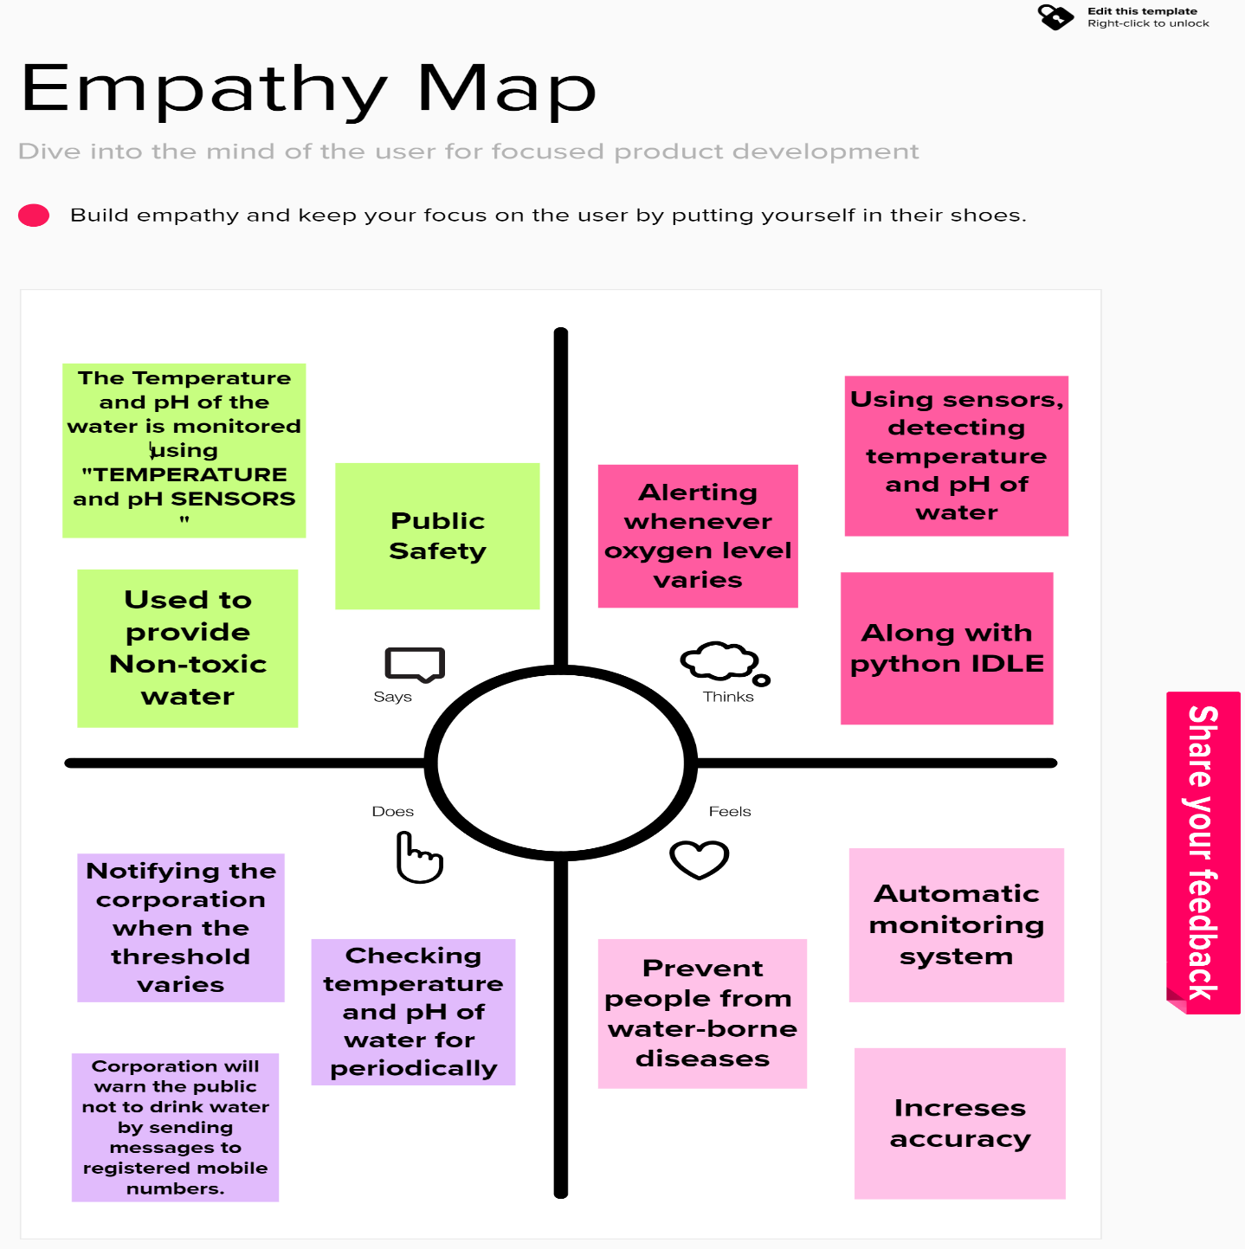

### Ideation & Brainstorming:

Brainstorming provides a free and open environment that encourages everyone within a team to participate in the creative thinking process that leads to problem solving. Prioritizing volume over value, out-of-the-box ideas are welcome and built upon, and all participants are encouraged to collaborate, helping each other develop a rich amount of creative solutions.

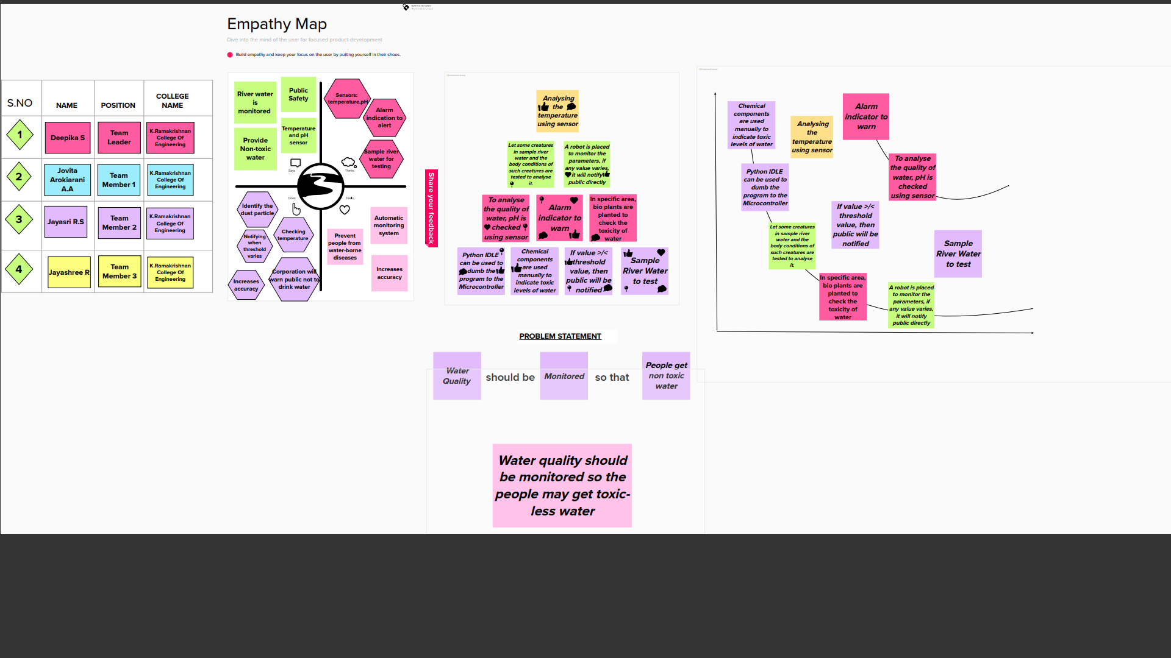

### Proposed Solution:

|  |  |  |
| --- | --- | --- |
| **S.No.** | **Parameter** | **Description** |
| 1. | Problem Statement (Problem to be solved) | “Real Time River Water Quality Monitoring and Control System” is an attempt to develop a general sensor and data model for monitoring water quality. The parameters for determining the quality of water are the pH level, turbidity and temperature. |
| 2. | Idea / Solution description | Real-time system was proposed to measure river water quality. With this system, real-time data can be collected from the active site and analysed at a remote server. |
| 3. | Novelty / Uniqueness | The uniqueness of our proposed project is to obtain the water monitoring system with high frequency, high mobility, and low powered. |
| 4. | Social Impact / Customer Satisfaction | It socially help water system managers identify threats to surface water earlier, make more fully informed decisions affecting the systems and the public they serve, and comply with ever-changing regulatory water quality monitoring requirements  at federal, state and local levels. |
| 5. | Business Model (Revenue Model) | It helps businesses, as river water is a primary source to drive the economic engines of irrigation and hydropower. |
| 6. | Scalability of the Solution | It has a good scalability because it prevents from infection and provides a healthy life. |

* 1. **PROBLEM SOLUTION:**

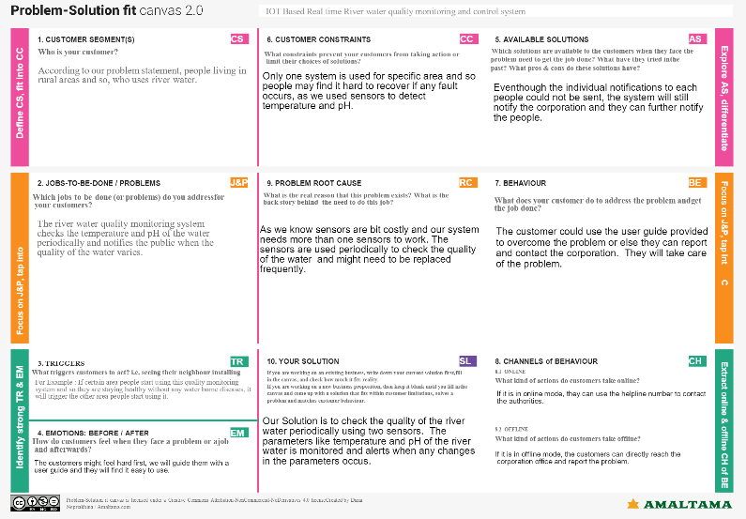

1. **REQUIREMENT ANALYSIS**

#### Functional Requirements:

Following are the functional requirements of the proposed solution.

|  |  |  |
| --- | --- | --- |
| **FR No.** | **Functional Requirement (Epic)** | **Sub Requirement (Story / Sub-Task)** |
| FR-1 | User Requirement | River Water Protection using pH and Humidity |
| FR-2 | User Registration | Registration through Form Registration through Email  Registration through Linkedin |
| FR-3 | User Confirmation | Confirmation Via Email Confirmation Via OTP Confirmation Via SMS |
| FR-4 | Payment Options | Credit,Debit and ATM Card Cash on delivery  UPI/QR Code |
| FR-5 | Product Delivery and Installation | Free Installation |
| FR-6 | Product Feedback | Through GoogleForm Through WebPage |

#### Non-functional Requirements:

Following are the non-functional requirements of the proposed solution.

|  |  |  |
| --- | --- | --- |
| **FR No.** | **Non-Functional Requirement** | **Description** |
| NFR-1 | **Usability** | Monitoring provides the objective evidence necessary to make sound decisions on managing  water quality today and in the future |
| NFR-2 | **Security** | It is secured for the customer as the quality of water is detected frequently. |
| NFR-3 | **Reliability** | The customer could use the userguide provided to overcome the problem or else they can contact the corporation. |
| NFR-4 | **Performance** | Used to detect the quality of water in frequent intervals. |
| NFR-5 | **Availability** | When it fails to alert every individual we have  sent a notification to the corporation which alerts the entire region. |

|  |  |  |
| --- | --- | --- |
| NFR-6 | **Scalability** | It has a good scalability because it prevent the people from diseases. |

1. **PROJECT DESIGN**

### Data Flow Diagrams:

A Data Flow Diagram (DFD) is a traditional visual representation of the information flows within a system. A neat and clear DFD can depict the right amount of the system requirement graphically. It shows how data enters and leaves the system, what changes the information, and where data is stored.

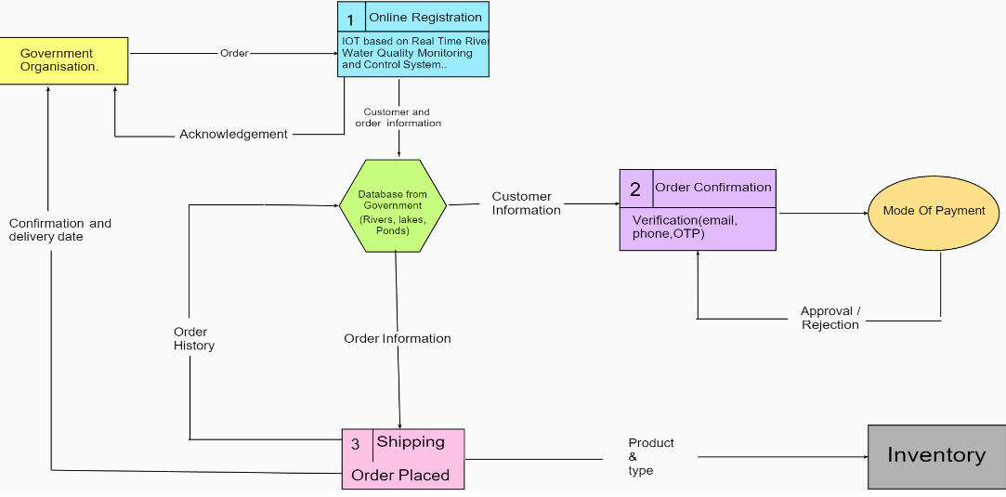

* 1. **SOLUTION AND TECHNICAL ARCHITECTURE**

**Summary**

This code pattern explains how to build an IOT based river water monitoring and controlling system with some predefined values.

Flow

* + - Feed the data received from the Sensor unit which are placed in the river sides.
    - The collected data will be displayed in the Web page to the user.
    - Then the collected data is sent to the data base, where the collected data and the predefined data are checked and monitored.
    - If any data exceed the predefined data then the control signal will send to the Admin.
    - The collected data will be stored in the IBM cloud storage. Later the data will be controlled by the admin via UI.

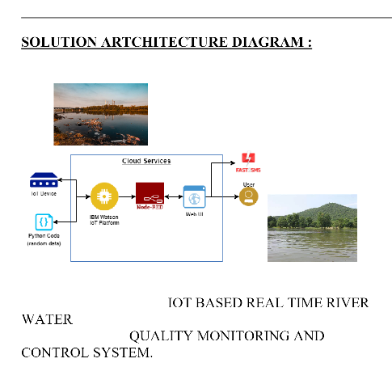

* 1. **CUSTOMER JOURNEY MAP**

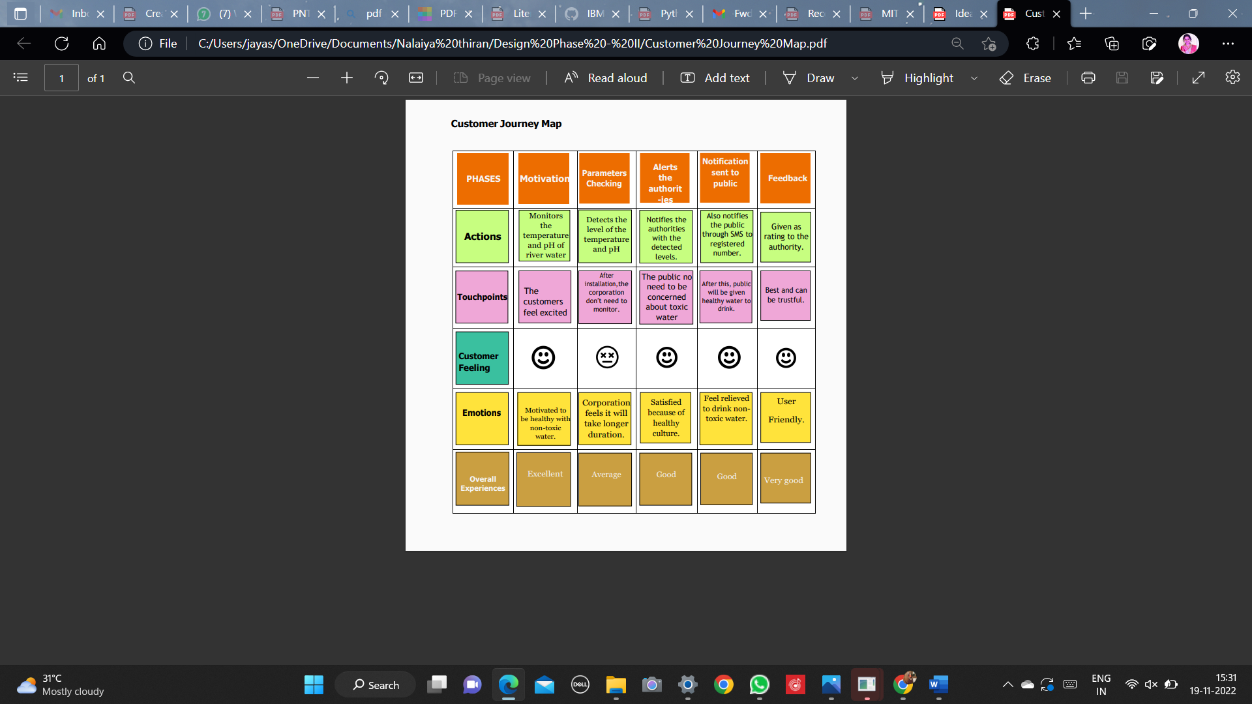

**6.PROJECT PLANNING PHASE**

|  |  |  |
| --- | --- | --- |
| **TITLE** | **DESCRIPTION** | **DATE** |
| **Literature Survey & Information Gathering** | A literature  review is a comprehensive summary of previous researches on the topic. The literature review surveys scholarly articles, books, and other sources  relevant to a particular area of research. | 03 SEPTEMBER  2022 |
| **Empathy Map** | An empathy map is a collaborative tool teams can use to gain a deeper insightinto their customers. It helps us to understand the customer’s pain, gain and  difficulties from their point of view. | 10 SEPTEMBER  2022 |
| **Ideation** | Brainstorming is a group problem- solving method that helped us to gather and organize various ideas and thoughts from teammembers. | 17 SEPTEMBER  2022 |
| **Proposed Solution** | It helped us analyze and examine our solution more in the grounds of uniqueness, social impact, business model, scalability etc. | 26 SEPTEMBER  2022 |
| **Problem Solution Fit** | It helped us understand and analyze all the thoughts of our customer, their choice of options, problems, root cause,behaviour and  emotions. | 28 SEPTEMBER  2022 |

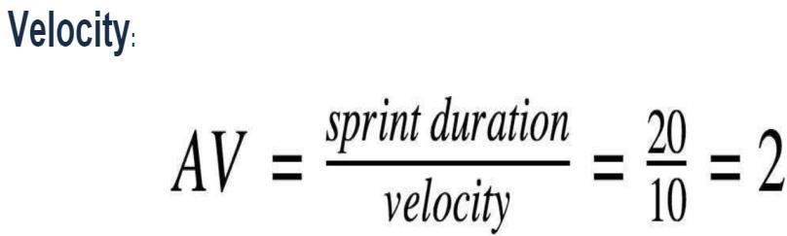

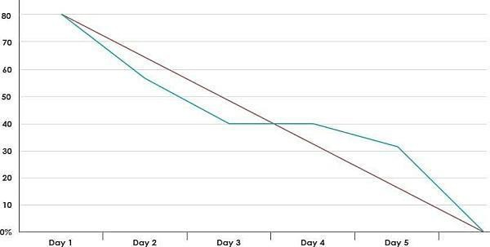**Burndown Chart:**

## CODING AND SOLUTIONING

**7.1 NODE RED SERVICE ASSOCIATED WITH IBM CLOUD:**

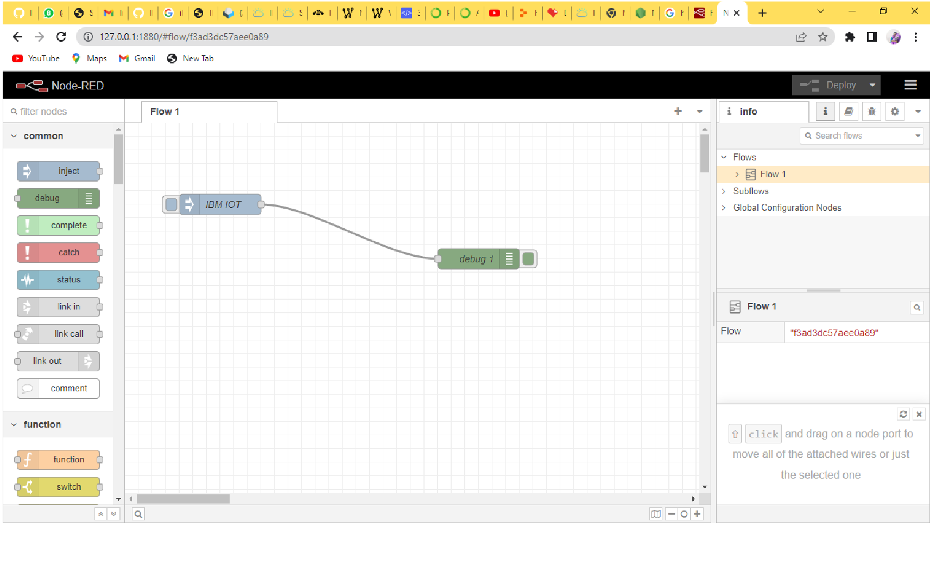

**08.TESTING**

**8.1Test Case Analysis**

This report shows the number of test cases that have passed, failed, and untested

|  |  |  |  |  |
| --- | --- | --- | --- | --- |
| **Section** | **Total Cases** | **Not Tested** | **Fai l** | **Pass** |
| Print Engine | 15 | 0 | 0 | 15 |
| Client Application | 45 | 0 | 0 | 45 |
| Security | 1 | 0 | 0 | 1 |
| Outsource Shipping | 2 | 0 | 0 | 2 |
| Exception Reporting | 10 | 0 | 0 | 10 |
| Final Report Output | 4 | 0 | 0 | 4 |
| Version Control | 3 | 0 | 0 | 3 |

|  |  |  |  |  |  |  |  |
| --- | --- | --- | --- | --- | --- | --- | --- |
| **Test**  **case id** | **Feature** | **Component** | **Test Scenario** | **Steps to Execute** | **Test Data** | **Actual Result** | **Status** |
| Login page | Functional | Home page | Verify user is able to see the Given app | 1. Download the given APK File 2. Click on download button 3. Verify login popup displayed   or not" | APK File | Working as expected | Pass |
| Login page | Functional | Home page | Verify user is able to see the Login/Signup popup when user open the Aqua  Meter | 1. Download the given APK File 2. Click on download button 3. Verify login popup displayed or not" | APK File | Working as expected | Pass |
| Login page | Functional | Home page | Verify the UI elements in Login/Signup popup | 1. Download the given APK File 2. Click on download button 3. Verify login popup with below UI elements:   A .Username text box  A .password text box  B .Submit button | APK File | Working as Expected | Pass |
| Login Page | Functional | Home page | Verify user is able to log into application with Valid credentials | "1 Download the given APK File   1. Click on download button 2. Enter Valid   “Given “ username in Username text box   1. Enter valid password in password text box 2. Click on Submit   button" | Username: Username  Password: Password | Working as Expected | Pass |
| Login Page | Functional | Home page | Verify user is able to see  the output | 1. output displayed | APKFile | Working as  Expected | Pass |

1. **RESULT**
   1. **PERFROMANCE METRICS:**

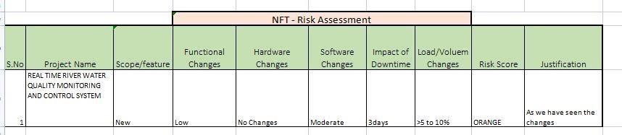

**PERFORMANCE TABLE**

|  |  |  |
| --- | --- | --- |
| PARAMETER | PERFORMANCE | DESCRIPTION |
| ADMIN TESTING | 95%-100% | THE TESTING DONE BEFORE IT IS DEPLOYED AS AN APP |
| CUSTOMER SATISFACTION | 75-85% | THE CUSTOMER NEED TO BE SATISFIED WITH THE MOBILE APPLICATION |
| USER INTERFACE | 65-85% | THE APP CAN USED BY ANYONE.(EASE OF ACCESS) |

|  |  |  |
| --- | --- | --- |
| SEVER RESPONSE | 50-75% | url - response |
| DATA VALIDATION WITH NO. OF TEST CASE | 60-80%  (15-30  TESTCASE) | VALID DATA FROM THE APP |
| ERROR | 3-5% | REAL-TIME DELAY MAY OCCUR |

1. **ADVANTAGES AND DISADVANTAGES**

**ADVANTAGES:**

* The prototype developed for water quality maintenance is very beneficial for safeguarding public health and also adds to the clean environment.
* The automation of this water monitoring, cleaning and control process removes the need of manual labor and thus saves time and money.
* The automation of the system makes the control and monitoring process more efficient and effective. Real time monitoring on mobile phone which is possible through the interface of plc with Arduino and Bluetooth module allows remote controlling of the system.

**DISADVANTAGES:**

* It is difficult to collect the water samples from all the area of the water body.
* The cost of analysis is very high.
* The lab testing and analysis takes some time and hence the lab results does not reflect real time water quality measurement due to delay in measurement.
* The process is time consuming due to slow process of manual data collection from different locations of the water body.
* The method is prone to human errors of various forms.

1. **CONCLUSION**

Thus our project is used to Monitoring of Turbidity, PH & Temperature of Water makes use of water detection sensor with unique advantage and existing GSM network. The system can monitor water quality automatically, and it is low in cost and does not require people on duty. So the water quality testing is likely to be more economical, convenient and fast. The system has good flexibility. Only by replacing the corresponding sensors and changing the relevant softwareprograms, this system can be used to monitor other water quality parameters.

The operation is simple. The system can be expanded to monitor hydrologic, air pollution, industrial and agricultural production and so on. It has widespread application and extension value.By keeping the embedded devices in the environment for monitoring enables self protection (i.e., smart environment) to the environment. To implement this need to deploy the sensor devices in the environment for collecting the data and analysis. By deploying sensor devices in the environment, we can bring the environment into real life i.e. it can interact with other objects through the network.

Then the collected data and analysis results will be available to the end user through the Wi-Fi.

**FUTURE SCOPE**

We use water detection sensor has unique advantage.It consumes less time to monitor than a manual method for checking polluted levels,and notifies immediately to reduce affected rate of pollution in water.People who are living in rural areas near to the river will be very

satisfied with our idea.It will be useful to monitor water pollution in specific area.So this system prevent people from water pollution.It will be used for farming purpose to check quality water,temperature and PH level.Our Impact of this project is also create a social satisfaction for farmers too.The scalabilty of this project gives the addition of more different type of sensors.By interfacing the relay we can control the supply of water. We can also implement as a revenue model.This system could also be implemented in various industrial processes. The system can be modified according to the needs of the user and can be implemented along with lab view to monitor data on computers.

1. **APPENDIX**
   1. **SOURCE CODE:**

**PYTHON CODE TO PUBLISH DATA**

import ibmiotf.applicationimport ibmiotf.device import time import randomimport sys

#from twilio.rest import Client#import key

#Client = Client(keys.account_sid, keys.auth_token)

organization = "maci0x" deviceType = "raspberrypi"deviceId = "123" authMethod = "token" authToken = "12345678"

pH = random.randint(1, 14) turbidity = random.randint(1, 100)

temperature = random.randint(0, 100)

def myCommandCallback(cmd):

print("Command Received: %s" % cmd.data['command'])#print(cmd) status=cmd.data['command']if

status=="motoron":

print("motor is on") elif status ==

"motoroff":

print ("motor is off")else :

print("Please send proper command")

try:

deviceOptions = {"org": organization, "type": deviceType, "id": deviceId, "auth-method":authMethod, "auth-token": authToken}

deviceCli = ibmiotf.device.Client(deviceOptions)except Exception as e:

print("caught exception connecting device: %s" % str(e))sys.exit() deviceCli.connect()while True:

pH = random.randint(1, 14) turbidity = random.randint(1, 100)

temperature = random.randint(0, 100)

data = {'pH': pH, 'turbid': turbidity, 'temp': temperature}

def myOnPublishCallback():

print("Published pH= %s" % pH, "Turbidity:%s" % turbidity, "Temperature:%s" %temperature)

success = deviceCli.publishEvent("demo", "json", data, qos=0, on_publish=myOnPublishCallback)

if not success:

print("Not Connected to ibmiot")time.sleep(5) deviceCli.commandCallback = myCommandCallback

deviceCli.disconnect()

**OUTPUT**

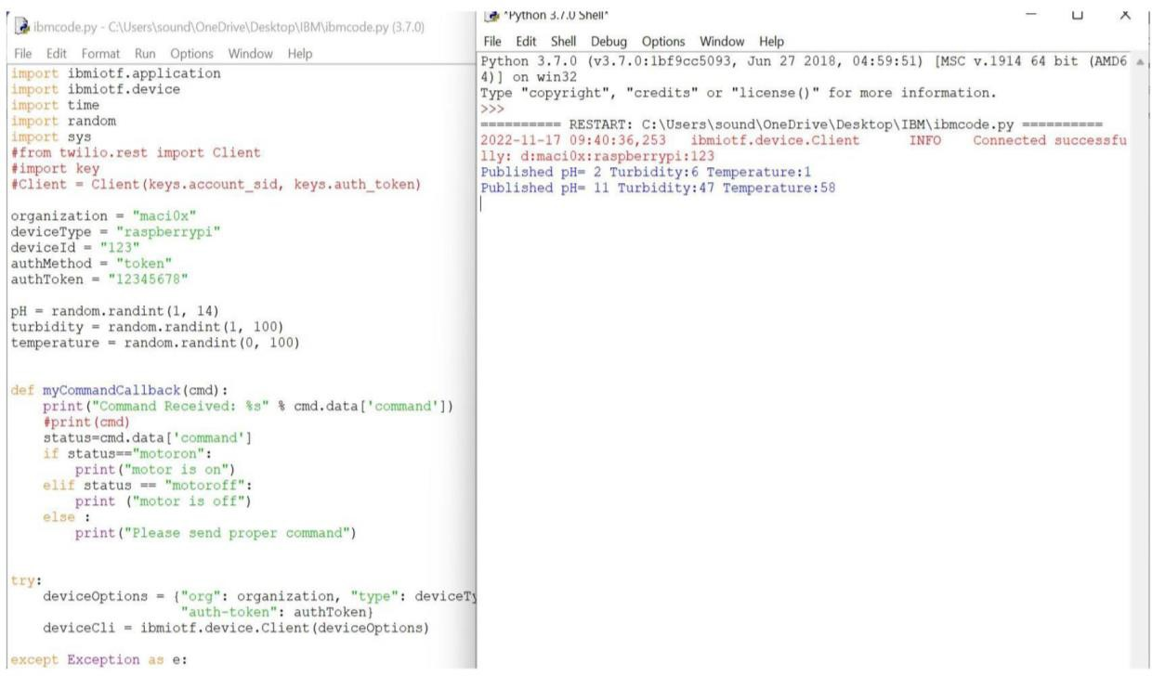

MOBILE APP:

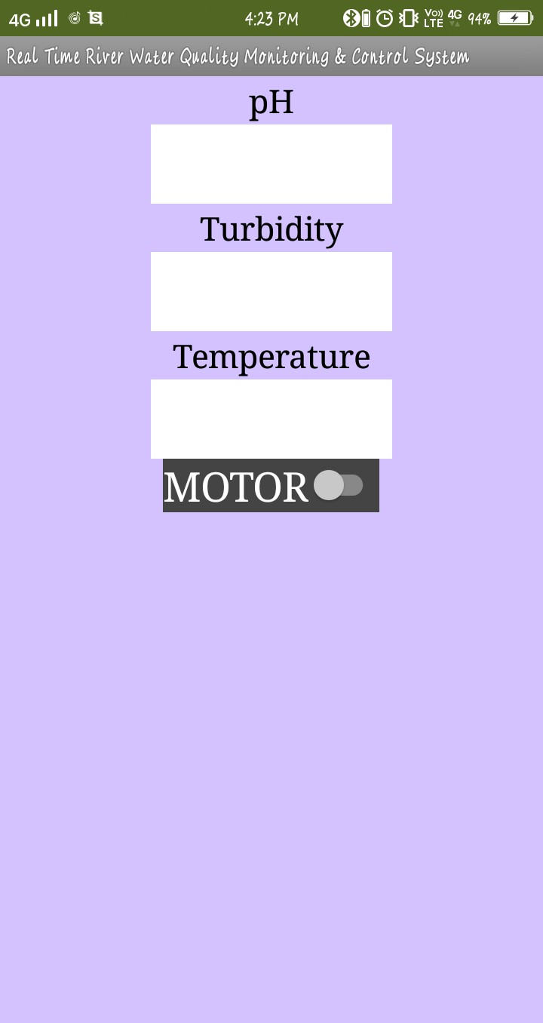

* 1. **GIT-HUB LINK:**

[**https://github.com/IBM-EPBL/IBM-Project-6161-1658824099**](https://github.com/IBM-EPBL/IBM-Project-6161-1658824099)